EXPERIMENT – 9
ROLL NO: 240701142 NAME: Gayathri Jayam S
Form Validation using HTML, CSS, JavaScript (Validator.js)
AIM
To design an input form that validates user data such as name, roll number, date of birth, email, and phone number, and displays appropriate error messages using HTML, CSS, JavaScript, and Validator.js.
TOOLS USED
• HTML
• CSS
• JavaScript
• Validator.js (CDN)

STEP 1: Setting Up the HTML Form
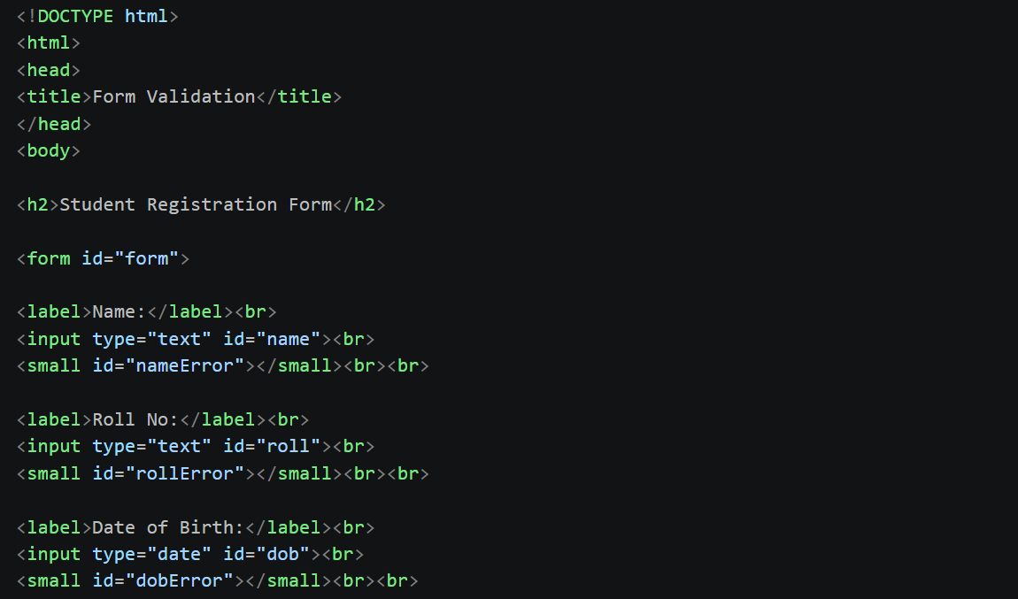
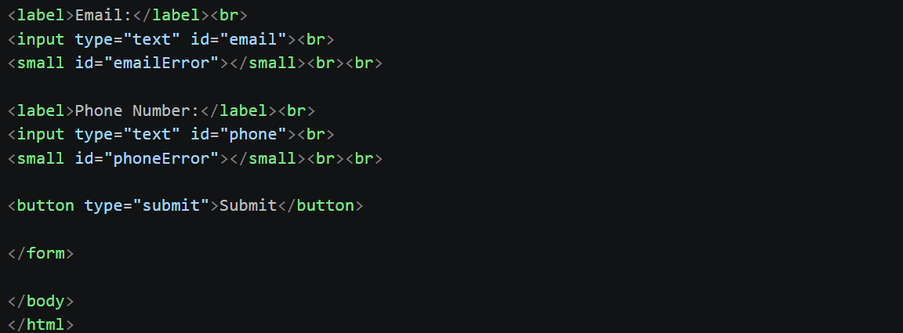
Output Screen:
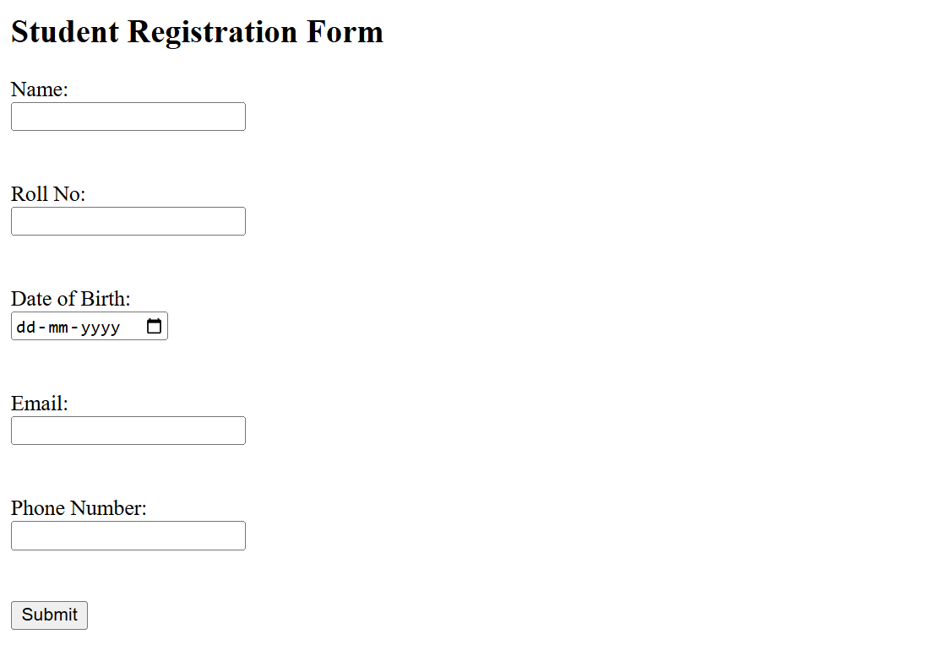

Explanation
• A basic HTML form is created with multiple input fields
• Each field has a corresponding <small> tag for error messages
• Input types:
- Text → Name, Roll No, Email, Phone
- Date → DOB
• No validation or styling is applied yet
STEP 2: Styling the Form with CSS
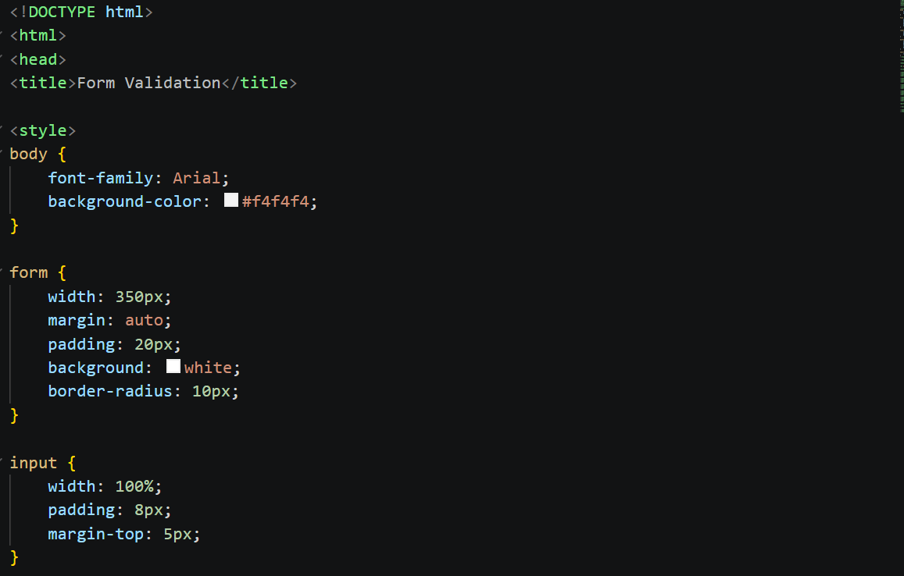
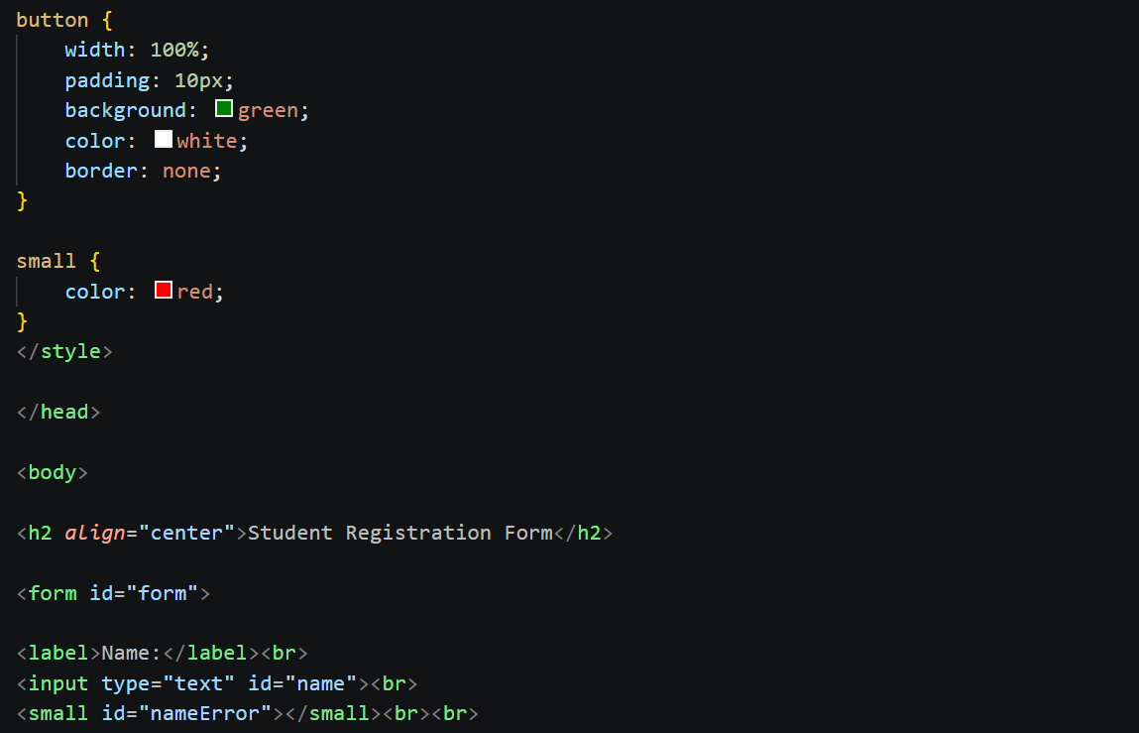
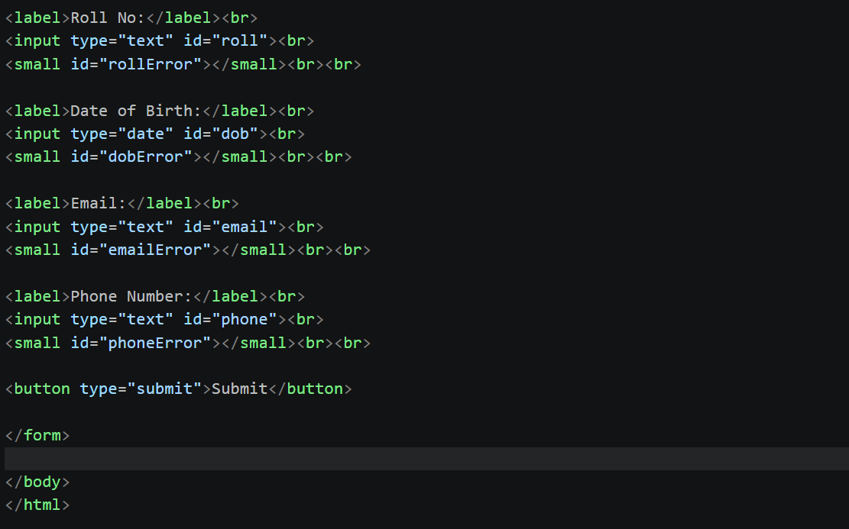

Output Screen:
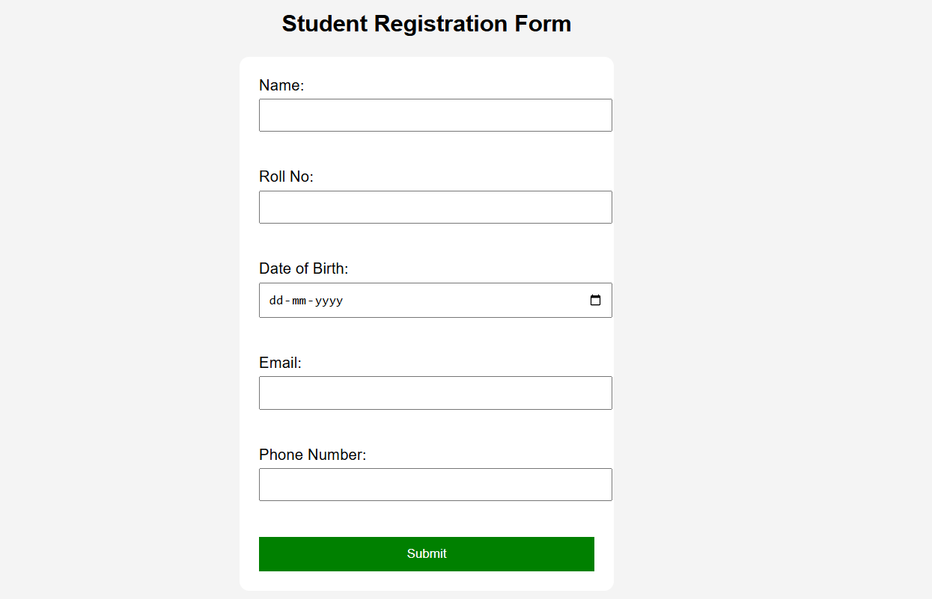

Explanation
• CSS improves the visual appearance
• Form is centered using margin auto
• Background color added to page
• Inputs and button styled for better UI
• Error messages are displayed in red color
• Still no validation logic

STEP 3: JavaScript Validation using Validator.js
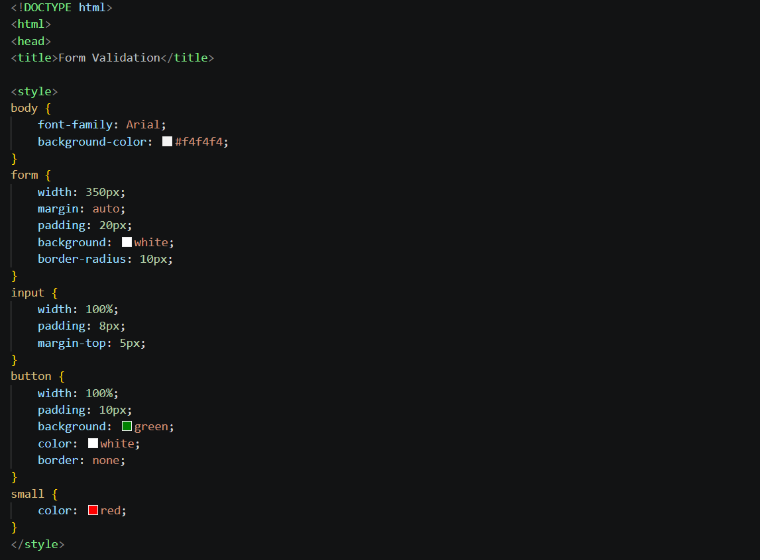
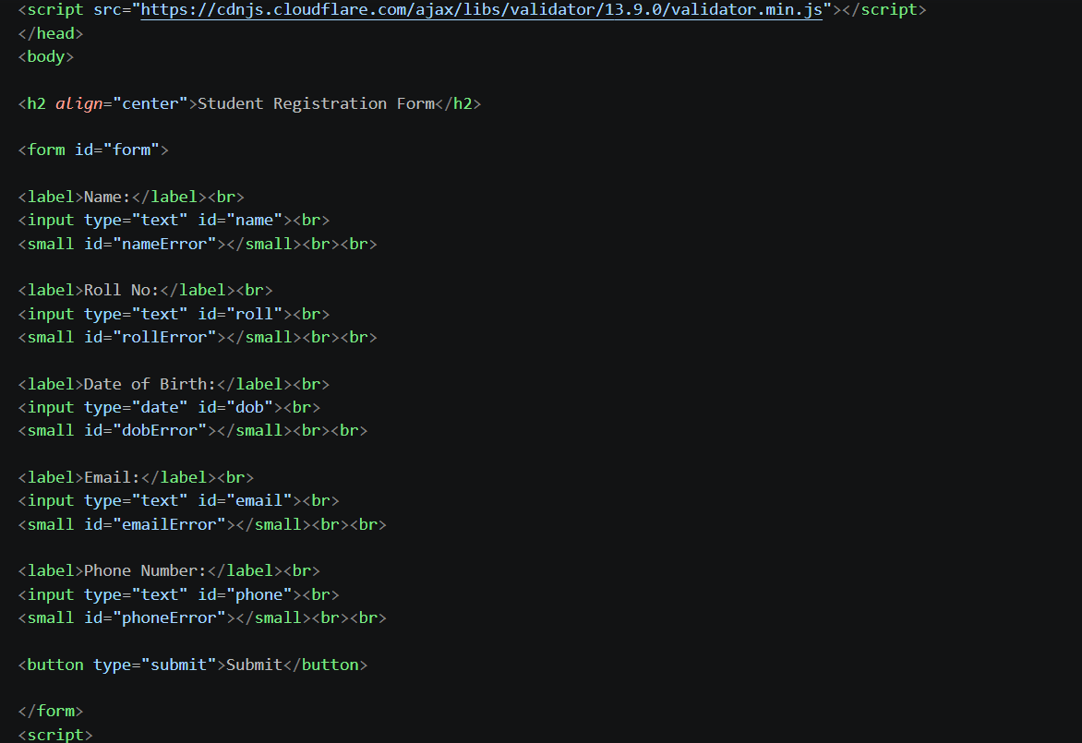
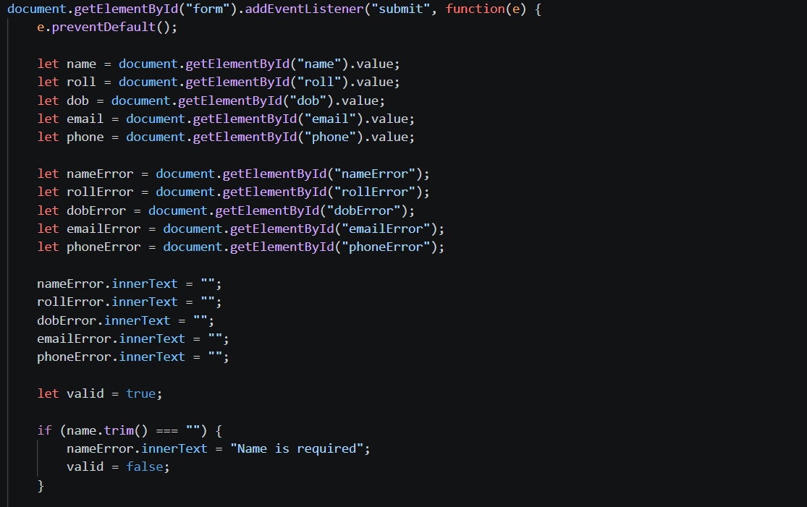
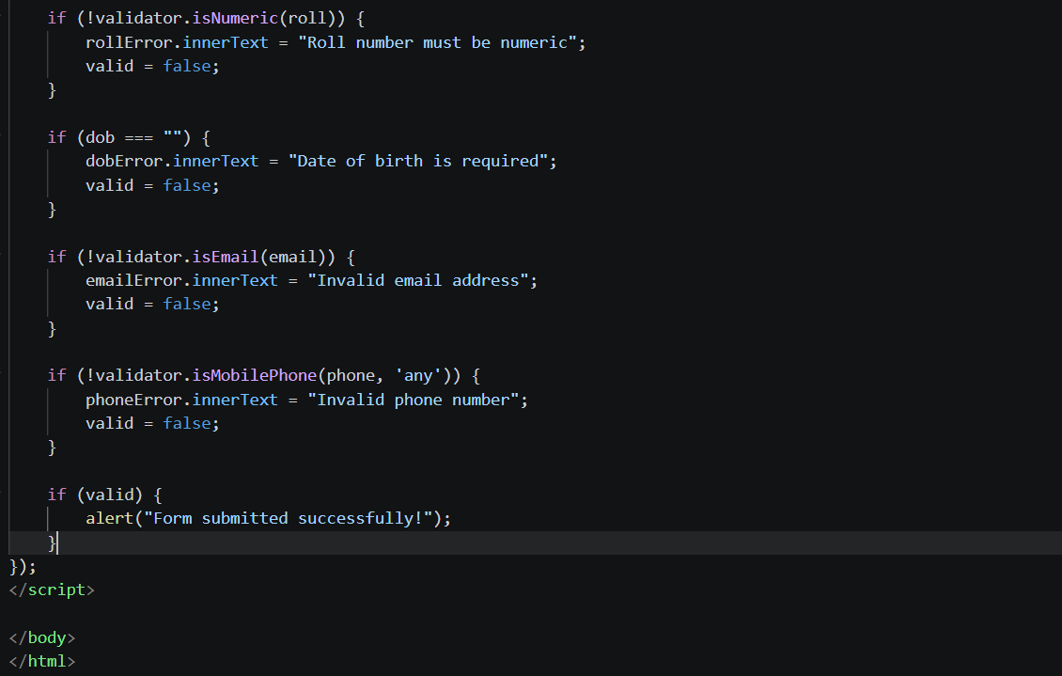

Output Screen:

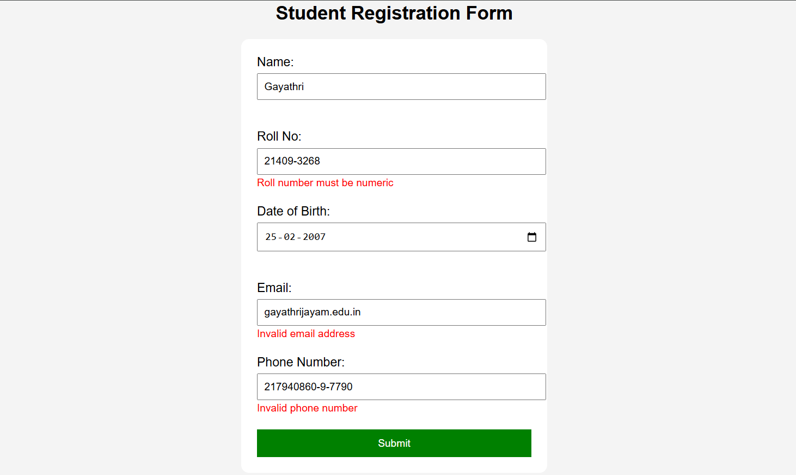

Explanation
• Validator.js is used for:
- Email → isEmail()
- Phone → isMobilePhone()
- Roll No → isNumeric()
• Custom validation:
- Name → cannot be empty
- DOB → must be selected
• Error messages:
- Displayed using <small> tags
- Cleared before each validation
• e.preventDefault() prevents page reload
• If all inputs are valid:
- Success message is shown

RESULT
The input form was successfully designed with validation for name, roll number, date of birth, email, and phone number using HTML, CSS, JavaScript, and Validator.js. Appropriate error messages are displayed for invalid inputs.

CONCLUSION
Form validation ensures accurate data entry and improves user experience. Validator.js simplifies validation logic and provides reliable methods for checking inputs efficiently.

